Poznamky z chapter 8

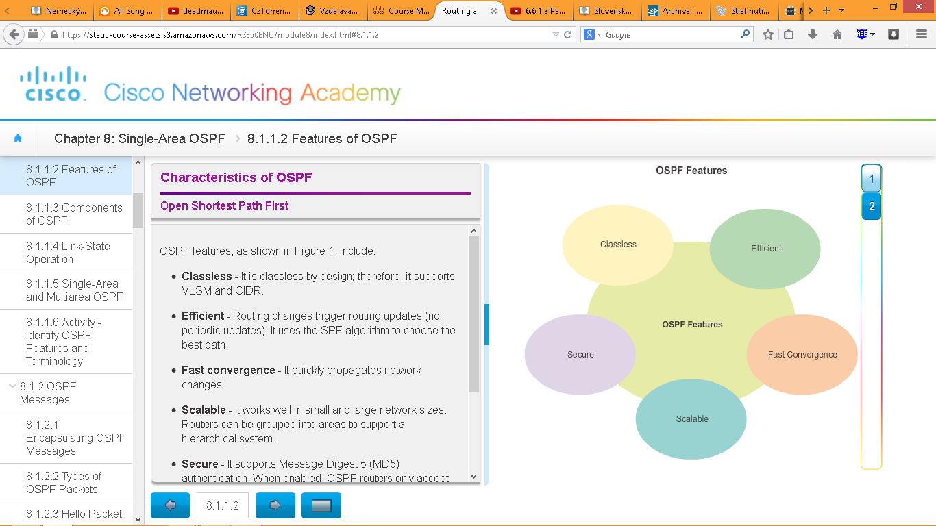

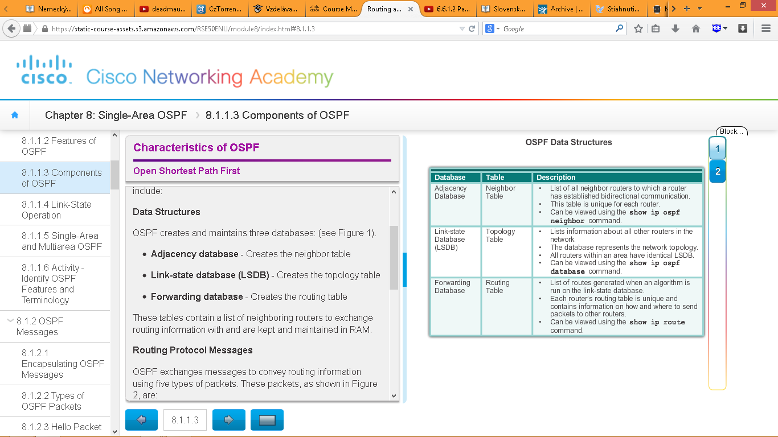

1. Establish Neighbor Adjacencies (Figure 1)

2. Exchange Link-State Advertisements (Figure 2)

3. Build the Topology Table (Figure 3)

4. Execute the SPF Algorithm (Figures 4 and 5)

Single-Area OSPF

Multiarea OSPF

Co sa posiela cez Ethernet

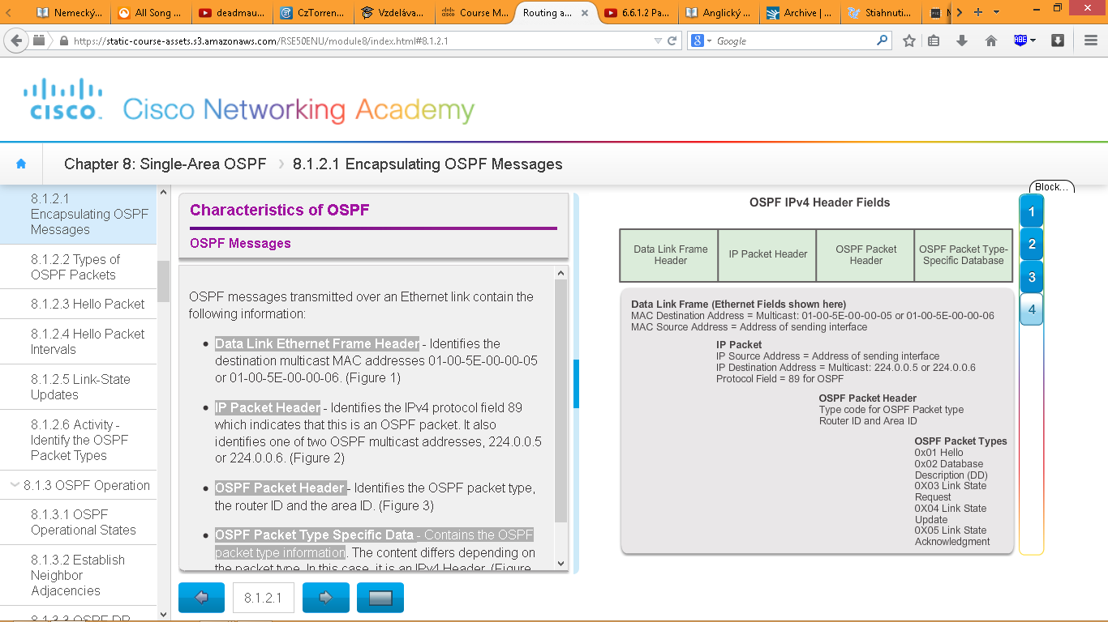

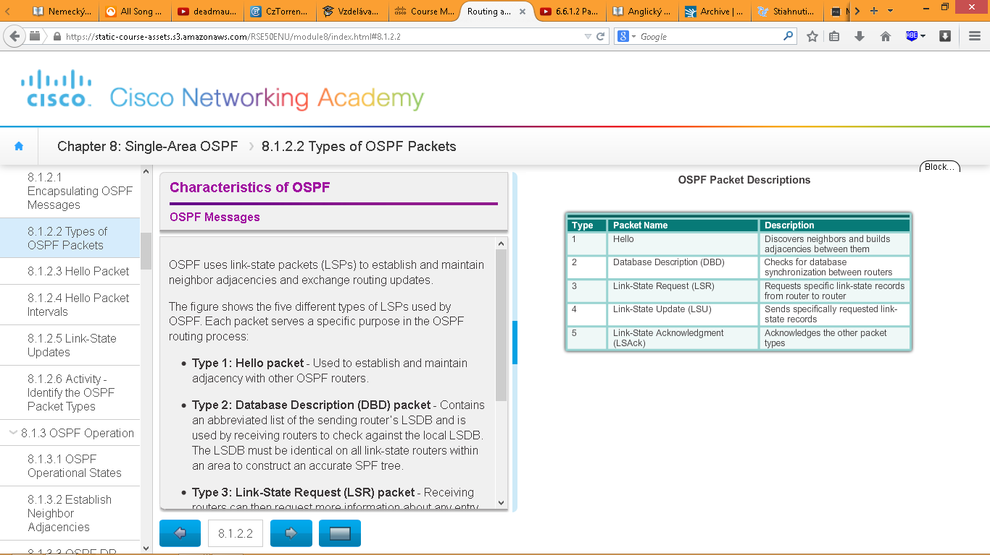

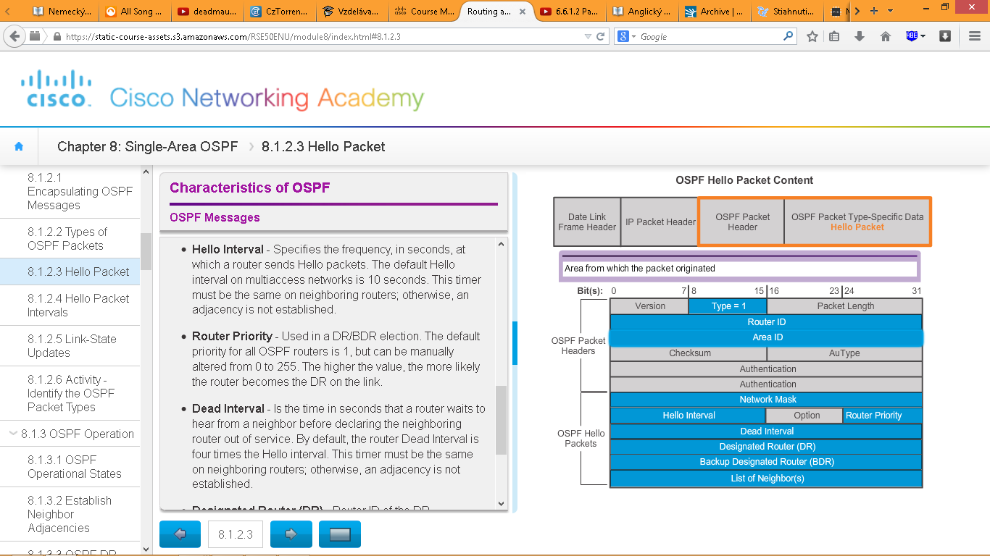

Hello interval – 10s

Dead interval – 40s

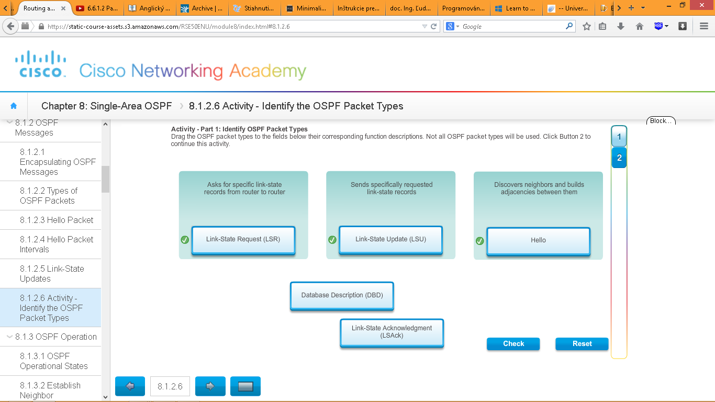

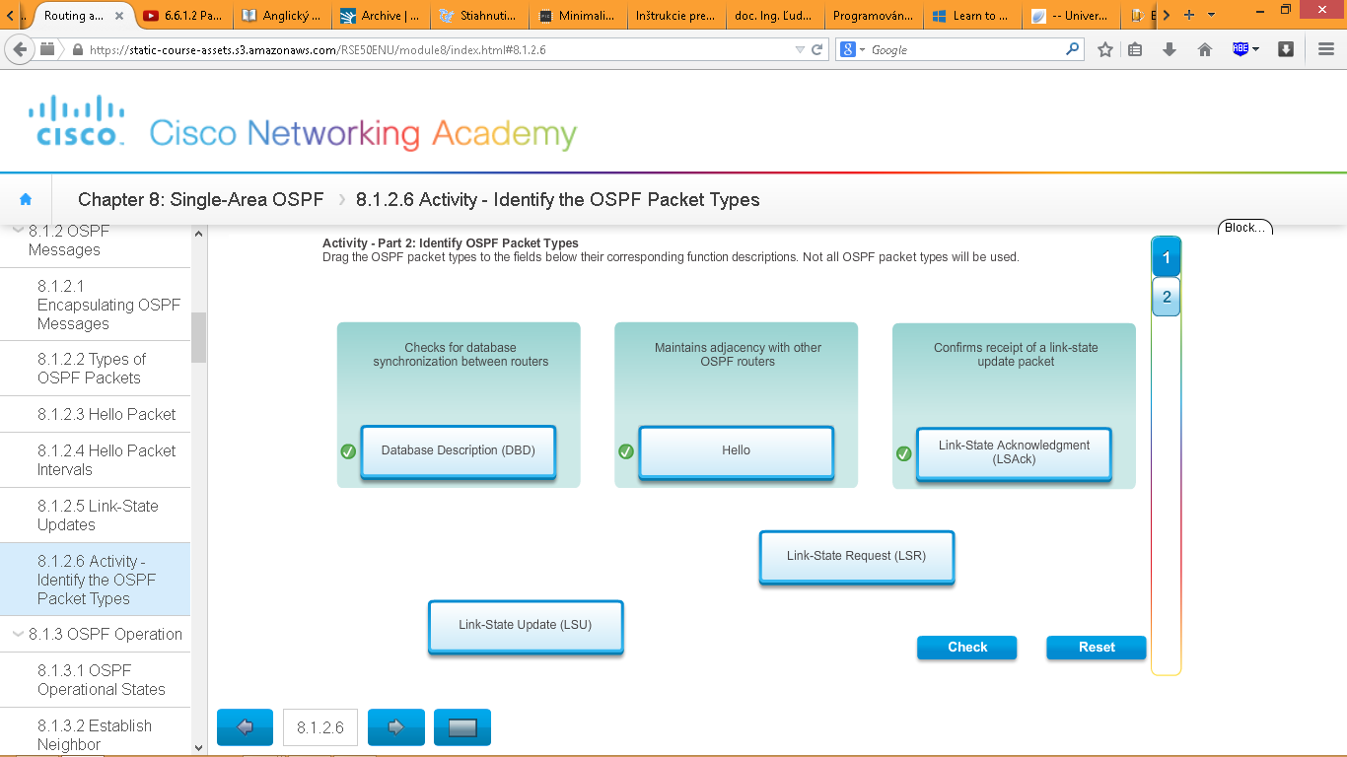

OSPF progresses through several states while attempting to reach convergence:

**Vytvaranie prilahlosti:**

1. **D**own state – neposielaju sa ziadne hello pakety
2. **I**nit state – zacinaju sa posielat hello pakety
3. Two-Way state – protocol si voli DR (Designated Router) a BDR (Backup Designated Router)

**Synchronizacia OSPF databaz:**

1. **E**xStart state – volba mastra/slave-a, zvoli sa DBD sekvencne cislo, master router zacina vymenu DBD paketov
2. **E**xchange state – routre si vymienaju DBD pakety, ak su pozadovane dalsie informacie, skoc na loading state, inak chod na full state
3. **L**oading state – vymienaju sa LSA a LSU

**Hotovo:**

1. **F**ull state – routre skonvergovali

Mnemo-pomocka:

D

I

T

E

E

L

F

OSPF sa zapina na interfejsi.

When OSPF is enabled on an interface, the router must determine if there is another OSPF neighbor on the link, preto posle HELLO paket

Why is a DR and BDR election necessary?

Multiaccess networks can create two challenges for OSPF regarding the flooding of LSAs:

* **Creation of multiple adjacencies** - Ethernet networks could potentially interconnect many OSPF routers over a common link. Creating adjacencies with every router is unnecessary and undesirable. It would lead to an excessive number of LSAs exchanged between routers on the same network.
* **Extensive flooding of LSAs** - Link-state routers flood their LSAs any time OSPF is initialized, or when there is a change in the topology. This flooding can become excessive.

To understand the problem with multiple adjacencies, we must study a formula:

For any number of routers (designated as *n*) on a multiaccess network, there are *n* (*n* – 1) / 2 adjacencies.

Figure 1 shows a simple topology of five routers, all of which are attached to the same multiaccess Ethernet network. Without some type of mechanism to reduce the number of adjacencies, collectively these routers would form 10 adjacencies:

5 (5 – 1) / 2 = 10

This may not seem like much, but as routers are added to the network, the number of adjacencies increases dramatically

If every router in a multiaccess network had to flood and acknowledge all received LSAs to all other routers on that same multiaccess network, the network traffic would become quite chaotic.

The solution to managing the number of adjacencies and the flooding of LSAs on a multiaccess network is the DR. On multiaccess networks, OSPF elects a DR to be the collection and distribution point for LSAs sent and received. A BDR is also elected in case the DR fails. All other routers become **DROTHERs**. A DROTHER is a router that is neither the DR nor the BDR.

Play the animation in Figure 4 to see the role of DR.

Each LSA entry header includes information about the link-state type, the address of the advertising router, the link’s cost, and the sequence number. The router uses the sequence number to determine the newness of the received link-state information.

Kto ma vyssie Router ID, ten je Master Router, druhy router je slave. Master router zacina vymenu databaz cez DBD pakety. Slave to potvrdi LSAck paketom a naspat posle svoju databazu. Master to potvrdi LSAck paketom. Ak chce jedna strana viac podrobnosti, tak si ich vyziada cez LSR a druha strana odpovie cez LSU pakety.

updates (LSUs) are sent only to neighbors when:

* A change is perceived (incremental updates)
* Every 30 minutes

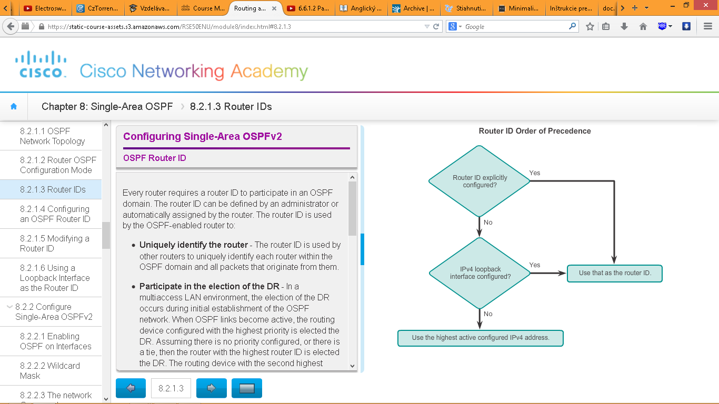Ako sa voli Router ID